**RESUME**

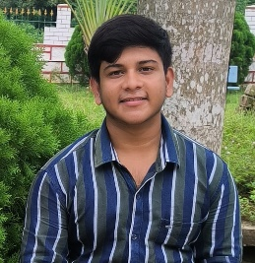**SUBRAT PANDA**

S/o- Sushanta Panda

At-Khamagan, Marsaghai, Kendrapara,

754213, Odisha

Mob-9353050929

Email ID –subratpanda018@gmail.com

***OBJECTIVE :***

Intend to build my career at an esteemed organization which would tell my knowledge, help to achieve my g oals and to move ahead in this competitive world while being resourceful, innovative and flexible.

***EDUCATIONAL QUALIFICATION :***

* persuing B.tech in Gandhi Institute of Excellent Technocrats in Bhubaneswar.
* Passed +2 Science from Tarini Science Residenitial Higher Secondary School in the year 2023
* Passed H.S.C from Nursingha Jew Nodal High School in the year 2021

***COMPUTER SKILLS :***

* Well versed with MS Word, Excel, Power Point, Outlook and Windows 2007 .
* Completed core Java , HTML , CSS , Java script , react , C , DSA , mysql .

***PERSONAL TRAITS :***

* Self motivated with a positive attitude.
* The ability to work in a team.
* Adaptable to the changes in my surroundings.
* I take initiative to improving the things and convince others to join me.
* Interested in exploiting my theoretical knowledge as practical.

***EXPERIENCE :***

* Lab Assistance in Sai Trishna Computer Care,
* Making salesforce UI using HTML,CSS ,JAVASCRIPT
* Making tic tac game JAVA with DSA

***PERSONAL DETAILS :***

Name : Subrat Panda

Father’s Name : Sushanta Panda

Date of Birth : 27.12.2005

Marital Status : Singal

Languages Known : Oriya, Hindi & English

Nationality : Indian

Religion : Hindu

Gender : Male

***DECLARATION :***

I consider myself fit and efficient for all type of situations and conditions. I am also confident of my ability to work in a team as I have proved it in my school, college and work field.

I hereby declare that the information furnished above is true to the best of my knowledge.

**Place: Kendrapara**

**Subrat Panda**